**DAILY ONLINE ACTIVITIES SUMMARY**

|  |  |  |  |  |  |  |  |  |
| --- | --- | --- | --- | --- | --- | --- | --- | --- |
| **Date:** | **20/06/2020** | | | | | **Name:** | **NAIPUNYA VINOD NAIK** | |
| **Sem & Sec** | **IV SEM & A SECTION** | | | | | **USN:** | **4AL18CS050** | |
| **Online Test Summary** | | | | | | | | |
| **Subject** | | **DATA COMMUNICATION** | | | | | | |
| **Max. Marks** | | **30** | | **Score** | | | **25** | |
| **Certification Course Summary** | | | | | | | | |
| **Course** | **1)GO PROGRAMMING LANGUAGE**  **2)** ETHICAL HACKING BIG BOUNTY COURSE  **3)** CYBER SECURITY PENETRATION TESTING TOOLS COURSE | | | | | | | |
| **Certificate Provider** | | | **UDEMY** | | **Duration** | | | **1)2 HRS**  **2)35 MIN**  **3)34 MIN** |
| **Coding Challenges** | | | | | | | | |
| **Problem Statement:1)** [Write a Java program to count number of bits to be flipped to convert A to B](https://github.com/orgs/alvas-education-foundation/teams/2nd-year/discussions/132).  2) Write a Java [Program that compares counting words in files using an ArrayList and a Map](https://github.com/orgs/alvas-education-foundation/teams/2nd-year/discussions/131).  3):- [Write a C Program to rotate an array by K positions.](https://github.com/orgs/alvas-education-foundation/teams/2nd-year/discussions/130) | | | | | | | | |
| **Status: EXECUTED** | | | | | | | | |
| **Uploaded the report in Github** | | | | | **YES** | | | |
| **If yes Repository name** | | | | | <https://github.com/naipunya-naik/lockdown-coding/blob/master/JAVA%20CODING/flipconvert_20-06-2020.java>  <https://github.com/naipunya-naik/lockdown-coding/blob/master/JAVA%20CODING/compare%20count_20-06-2020.java>  <https://github.com/naipunya-naik/lockdown-coding/blob/master/C%20CODING/rotate%20K%20position_20-06-2020.c> | | | |
| **Uploaded the report in slack** | | | | | **YES** | | | |

Online Test Details: (Attach the snapshot and briefly write the report for the same).

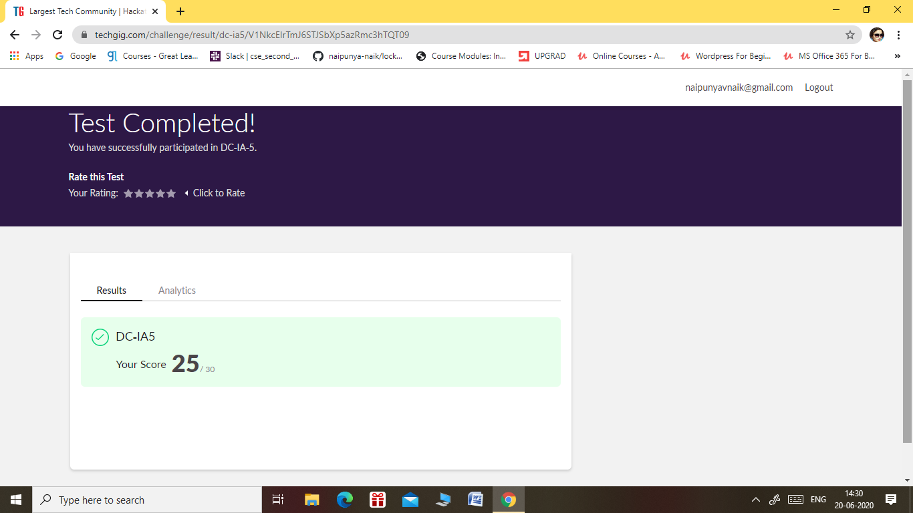

* THE 5TH I.A TEST OF SUBJECT DATA COMMUNICATION WAS CONDUCTED ON 20 JUNE, 2020.
* SUBJECT:- DATA COMMUNICATION
* SYLLABUS:- MODULE 3 AND MODULE 4
* NO.OF.QUESTIONS:- 30
* START TIME:- 2.00 PM
* END TIME:- 2.30PM
* DURATION:- 30 MIN
* EACH QUESTION CARRIED 1 MARK

Certification Course Details: (Attach the snapshot and briefly write the report for the same).

CERTIFICATION COURSE NAME:- GO PROGRAMMING LANGUAGE

DURATION:- 2 HRS



2) CERTIFICATION COURSE NAME:- ETHICAL HACKING BIG BOUNTY COURSE

DURATION:- 35 MIN

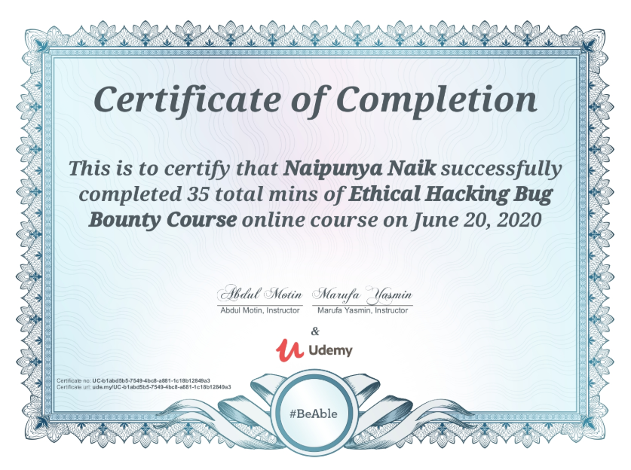

3) CERTIFICATION COURSE NAME:-

CYBER SECURITY PENETRATION TESTING TOOLS COURSE

DURATION:- 34 MINS



Coding Challenges Details: (Attach the snapshot and briefly write the report for the same).

PROBLEM STATEMENT:-

[Write a Java program to count number of bits to be flipped to convert A to B](https://github.com/orgs/alvas-education-foundation/teams/2nd-year/discussions/132)

Top of Form

Bottom of Form

|  |
| --- |
| Given two numbers ‘a’ and b’. Write a program to count number of bits needed to be flipped to convert ‘a’ to ‘b’. **Example :**  Input : a = 10, b = 20 Output : 4 Binary representation of a is 000**0101**0 Binary representation of b is 00010100 We need to flip highlighted four bits in a to make it b.  Input : a = 7, b = 10 Output : 3 Binary representation of a is 0000**01**1**1** Binary representation of b is 00001010 We need to flip highlighted three bits in a to make it b.  **Hint**   1. Calculate XOR of A and B. a_xor_b = A ^ B 2. Count the set bits in the above calculated XOR result. countSetBits(a_xor_b) |

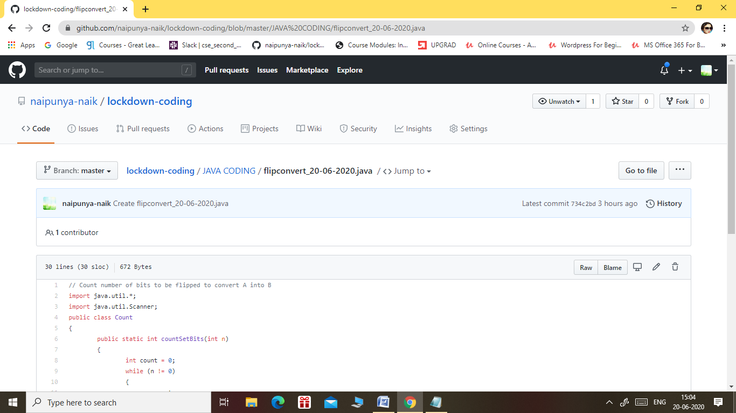

GITHUB REPOSITORY LINK:-

<https://github.com/naipunya-naik/lockdown-coding/blob/master/JAVA%20CODING/flipconvert_20-06-2020.java>

PROBLEM STATEMENT 2:- [Program that compares counting words in files using an ArrayList and a Map](https://github.com/orgs/alvas-education-foundation/teams/2nd-year/discussions/131).

Use java for coding

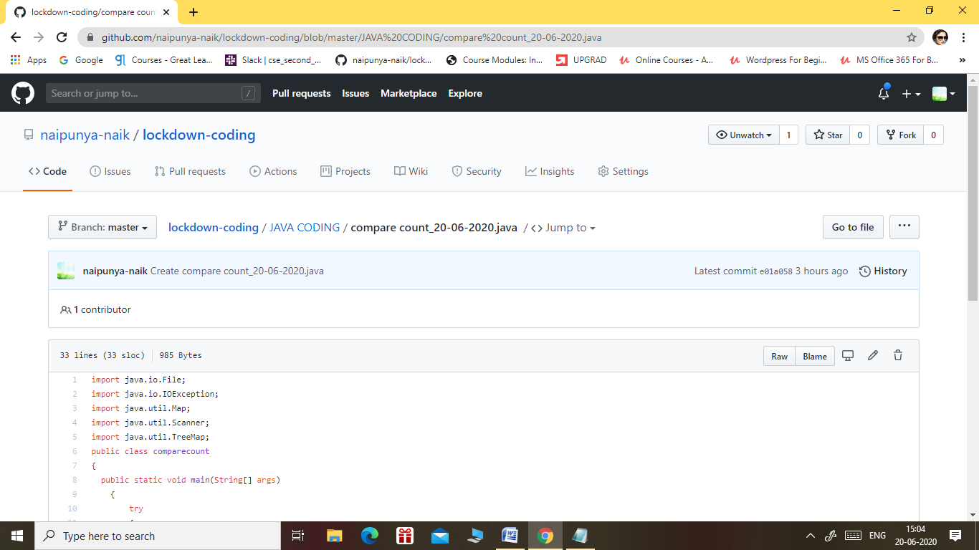

GITHUB REPOSITORY LINK:-

<https://github.com/naipunya-naik/lockdown-coding/blob/master/JAVA%20CODING/compare%20count_20-06-2020.java>

PROBLEM STATEMENT 3:- [Write a C Program to rotate an array by K positions.](https://github.com/orgs/alvas-education-foundation/teams/2nd-year/discussions/130)

Top of Form

Bottom of Form

|  |
| --- |
| Circular array rotation means rotating the elements in the array where one rotation operation moves the last element of the array to the first position and shifts all remaining elements to the right.  For example, consider the following array = [4, 5, 6], • Initial array [4, 5, 6] • After one rotation [6, 4, 5] • After two rotations [5, 6, 4]  OUTPUT  Element at index 0: 5 Element at index 1: 6 Element at index 2: 4 |

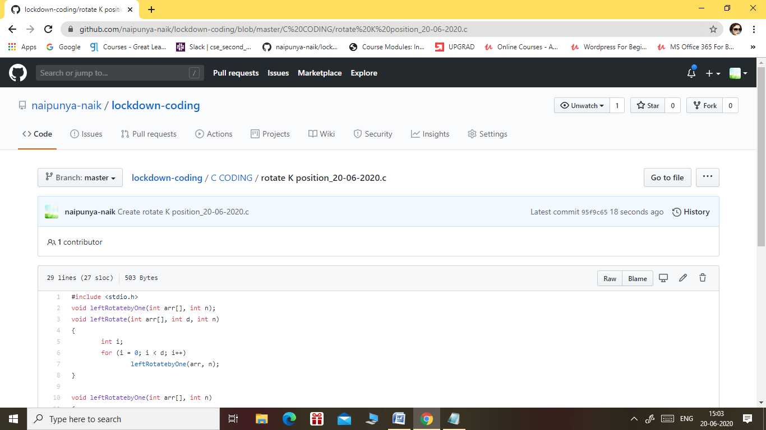

GITHUB REPOSITORY LINK:-

<https://github.com/naipunya-naik/lockdown-coding/blob/master/C%20CODING/rotate%20K%20position_20-06-2020.c>